Circuit diagrams
For an electrical circuit to work properly, electricity must be able to flow around the circuit freely. This is called a complete (or closed) circuit. When electricity isn’t flowing around a circuit, it is called an incomplete (or open) circuit.
Adding a switch to a complete circuit allows the flow of electricity to be turned on or off. When the switch is open, electricity will not flow (incomplete circuit). When the switch is closed, the electricity will flow (complete circuit).
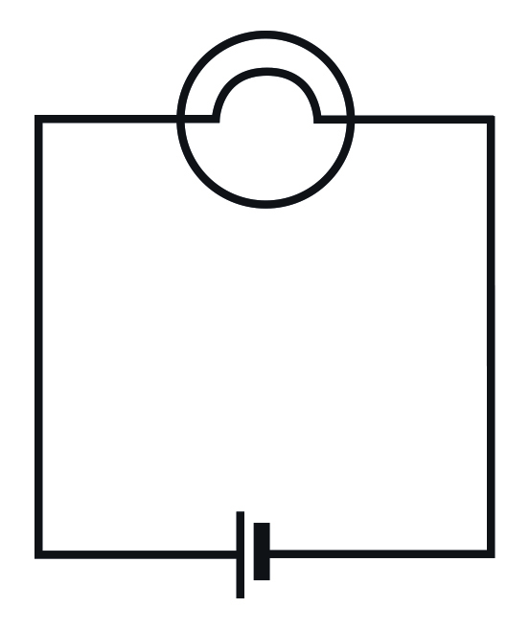 | 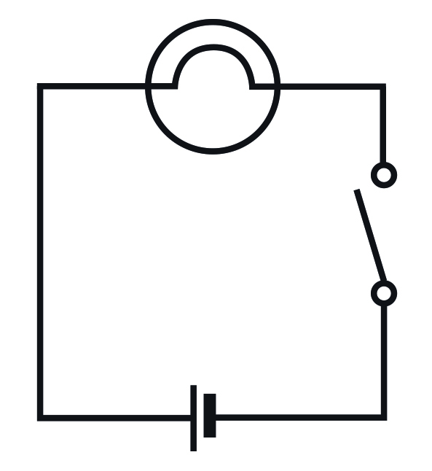 | 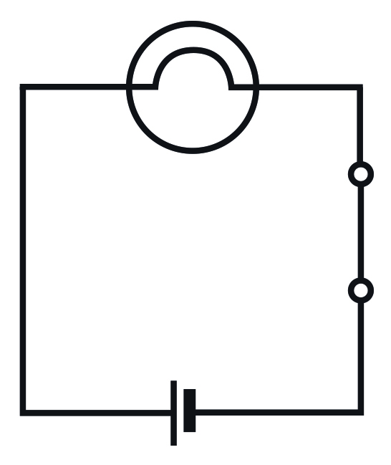
A simple complete circuit where the light bulb will be illuminated. | A simple circuit with a switch in the open position. The electricity will not flow so the light bulb will not be illuminated. This is an incomplete circuit. | A simple circuit with a switch in the closed position. The electricity can now flow around the circuit so the light bulb will be illuminated. This is a complete circuit.

Cell | Wire
Open  Closed | 
Switch | Light bulb

Buzzer

